Matchmaker
A MatLab tool for manual matching of
(palaeoclimate) time series

User's guide

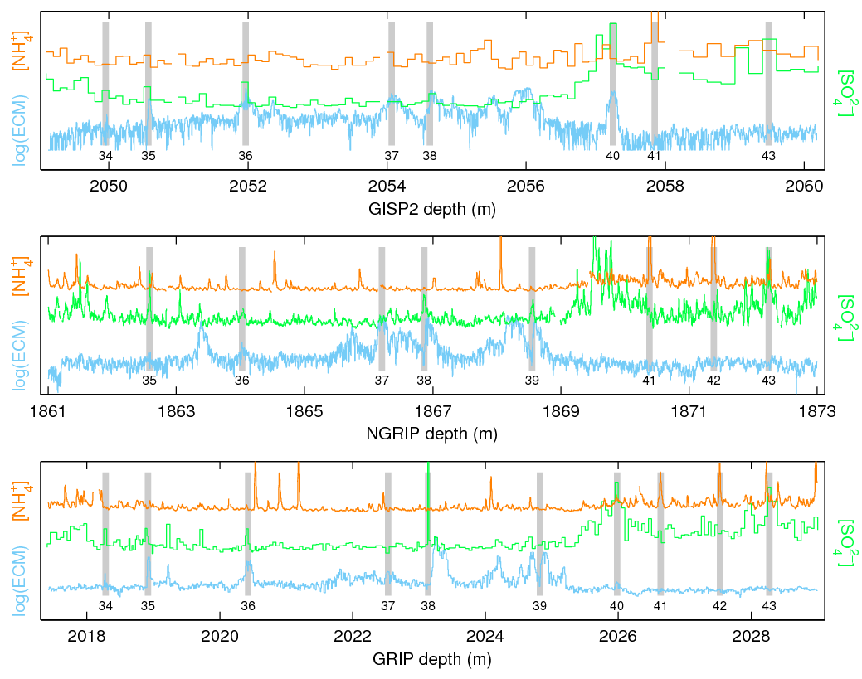

Sune Olander Rasmussen (contact: sune.rasmussen@nbi.ku.dk)
With edits by Giulia Sinnl (report Github issues: https://github.com/giulia-s/matchmaker /issues)
August 2025

Introduction
Matchmaker is a collection of MatLab scripts that form an application aiming at facilitating efficient and quality-checked matching of time series from different records. It is also convenient for browsing and inspecting large data sets with many parallel data series from one record.
It has been designed for use with ice core profiles, and some design issues clearly reflect this, but can essentially be used with any type of data, although the tool is probably not suited for working with data sets from many independent cores/sites.

Copyright issues
Matchmaker can be used free of charge for any private and academic purposes. Commercial use or redistribution is not permitted without prior permission.
You are free to edit the source code to fix malfunctions, add features, or change details in layout or user interface, but if you think that your changes represent an improvement to all (or even most) users, forward your suggestion to Sune for inclusion in future versions instead of changing your local version.
I kindly ask all users to register by e-mail to me in order to be able to provide updates and to get an overview of the user group.
Matchmaker is not foolproof (and will never be) and you may still be able to provoke errors that will cause loss of data. Therefore, please act responsibly and back up your match point files frequently. No liability is accepted for loss of data or other problems.

Technical issues and preparation

MatLab version
Matchmaker has been designed to work with MatLab 7.0 (R14) or newer. A MatLab 6.5 (13) version is available, but is considerably slower when working with large data files. No support is given to the old version.

Platform
Matchmaker has been developed on Windows XP/2000 Pro/7 platforms, but is known to work under Linux as well.

Files and folders
The program can run from any folder.
The program consists of the following files:
- matchmaker.m
- matchmaker_evaluate.m
- matchmaker_savefig.m
- matchmaker_sett.mat
- files_main.mat (user defined)
- The mandatory subfolder data, containing the appropriate data files for each ice core, as described below.
- The mandatory subfolder matchfiles, containing the appropriate data files for the tie points saved during a matchmaker session. Also, automatically generated by the program: the matchfiles/matchfiles_backup folder, containing backup versions of the matchfiles, as described further below.
- A template file for building Matchmaker data files make_data_file.m is also provided.
- This user guide

Format of input data

Files_main file format
You need to supply Matchmaker with a list of which cores and files to work with, all stored in a struct called files. Use the file "files_main.m" as an example and be aware of the numbering used. E.g.:
files.core{1} = 'Core1';
files.datafile{1} = 'core1_data.mat';
files.matchfile{1} = 'CORE1_core123match.mat';
files.matchfile_bis{1} = 'CORE1_core123match_version2.mat'; %(optional)

NOTE: Naming convention
It is important to note that, although one match point file is needed for each data file, the match files of a certain matching project belong together.
To prevent mistakes, it is recommended to use a naming convention where the core name and a suitable name of the matching project form the match file names. For example, in a project where three cores are matched, the following names would make sense: 'CORE1_core123match.mat', 'CORE2_core123match.mat', and 'CORE3_core123match.mat'.
Be careful to keep track of which files are used: if 3 records are matched up, nothing prevents you from opening Matchmaker with only the first two records and remove or add match points. However, if you modify the number of match points, the third record will no longer be matched to the two others, because Matchmaker assumes that all three match point files contain parallel ordered lists of match points that are valid in all three cores.

Data format (files.datafile)

An example of a MatLab script for building Matchmaker data files is provided (make_data_file.m). The format is designed to handle that most ice core data are available on common depth/time scales, and that it therefore often is unnecessary to save a depth/time scale for each data series.
In short, the data file must be an internal MatLab data format (.mat) file containing the following variables:
data cell array with N data series.
depth cell array with M depth (or time) scales.
depth_no vector of size N. Element number i tells which depth index to assign (see Figure 1).
species cell array with the N names of the data series.
colours Nx3 array with RGB colour definition for the plotting.
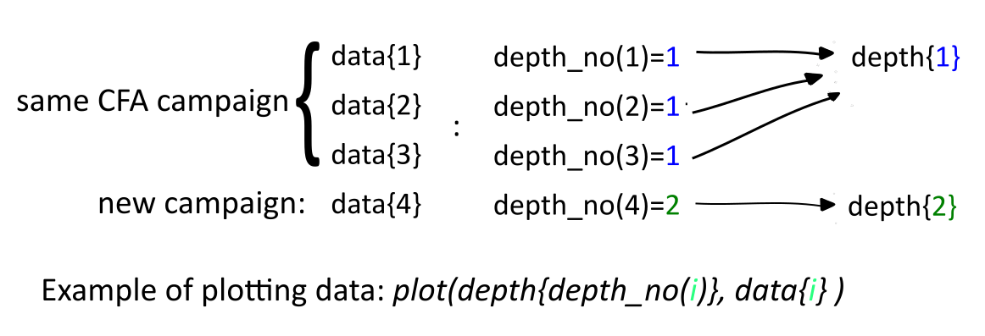
Figure 1 Schematic of how the arrays data and depth are connected by depth_no.

Match point file format (files.matchfile and files.matchfile_bis)

Match points are saved in the matchfiles folder. The workspace files must contain the array mp with 2 columns: depth (or time) and match point type (see below).

If files.matchfile(i) is not found, Matchmaker will create a new file named files.core(i).mat. The program will check for the existence of this file, and either load it or initialize an empty array mp=[]. You can keep working with this file but remember to use a naming convention suited for your project.
An optional, secondary file matchfile_bis can be added for each ice core to be able to compare a secondary set of tiepoints. See below for how to use this file.

Starting Matchmaker

The user can freely select how many cores to show and how many parallel data series to show for each core.
Matchmaker is started by issuing the e.g. following command in the MatLab prompt:
>> matchmaker('files_main', [1 2 3], [2 3 4]);
In this example, matchmaker reads from the initializing file files_main and opens the cores with number [1,2,3]. Each ice-core panel opens with [2,3,4] data axes, respectively.

Errors
Errors occur, although care has been taken to eliminate critical errors. MatLab warnings also occur on a regular basis.
In case of critical errors or warnings that sound worrying, cut-and-paste the error message from the MatLab prompt and send it to me by e-mail with a description of the action that caused the error to happen (or post it as an issue on the github of matchmaker).
Most errors are produced within a call-back, and often the application will be able to continue without problems. However, it is probably smart to save the match points and restart Matchmaker.

Closing down after critical errors
Following a full-fledged crash, it can be impossible to get MatLab to close the windows of Matchmaker or the evaluate window. The brute-force close-down procedure is this:
set(0, 'showhiddenhandles', 'on')
delete(gcf)
set(0, 'showhiddenhandles', 'off')

This series of commands closes the most recently accessed figure without any warnings or undo options. If you are trying to kill e.g. the Evaluate window , be very careful not to kill the Matchmaker window (without saving) by accident. It is not a pretty solution, but better than Ctrl+Alt+Del.

Too many matchpoints

When too many matchpoints are displayed, Matchmaker goes into ”energy saving mode” and won’t plot them all, instead prompting the user to reduce the x-axis range. The accordianizing still works as usual, but you can’t add any matchpoints.

Using Matchmaker

When the Matchmaker window has successfully opened, you start by choosing which of the data series to view and which depth/time interval to view them in (follow section on Scaling the axes). You are now ready to: look for common features in the different cores, match the records using mousedclicks, and visualize the resultsrby stretching stretch the data (“accordianizing”) or by using some evaluation tools providew.

Types of matchpoints (mp)

Figure 2 Types of matchpoints in matchmaker
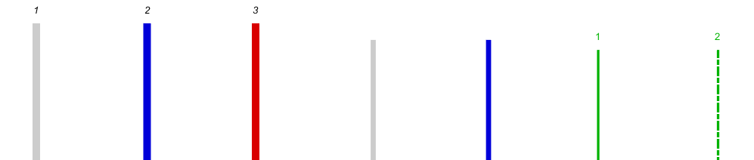

Seven types of match points can be set in the standard version of Matchmaker (Figure 2), and here we list the common convention for using them. To set new matchpoints in your Matchmaker instance, see the section on Buttons at the bottom of the screen, under Edit.
The matchpoints are grouped as follows:
- Reference mps, the main isochrone horizons, used to match ice cores together, under which we have:
- Thick grey bars, numbered (mp type=1), set at depths where common features are observed in the different records. They represent features that should be used to stretch the profiles. When pressing the accordianize button, the data series are stretched horizontally so that the first and last type 1 match points on the screen line up vertically.
- Thick blue bars, numbered (mp type=4), behave similar to grey bars but represent a "dummy" match point in the record(s) that do(es) not contain the feature, in order to maintain correct numbering of the match points. Type 4 match points are numbered and are equivalent to type 1 match points when accordianizing, but are represented with a separate symbol when evaluating.
- Thick red bars, numbered (mp type =3), are intended as “temporary” versions of type 1 match points. Often the matching is initially performed on long data sequences inspected in poor detail. Type 3 match points are conventionally set to mark likely match points, and a second inspection using high resolution data is then undertaken to replace the temporary match point with a type 1 match point (or to delete the match point). Type 3 match points are equivalent to type 1 match points when accordianizing or evaluating.
- Thin mps, the minor mps used to mark features in the data to support the matching:

- Thin grey bars, not numbered (mp type = 2), are match points representing finer, less certain match points, and are usually used to mark features or patterns that are likely to be synchronous. They play no role for the stretching of the data series.
- Thin blue bars, not numbered (mp type=5), are “dummies” for type 2 match points, just as type 4 match points are for type 1 match points.
- Years mps, the minor mps used to count the annual layers in each ice core, under which:
- Thin green bars, numbered (mp type = 6), are used to mark annual layers between reference horizons . The numbering is set to behave like so: if there are no reference mps on screen, the numbering starts at the left-most edge of the screen; if there are reference mps on screen, the numbering starts after the left-most reference mp.
- Even thinner green bars, numbered (mp type =7), are are used to mark annual layers that are uncertain. The numbering progresses together with type 6 bars.

Buttons at the bottom of the screen
Figure 3 : buttons of Matchmaker in the lower part of the GUI

The Save button saves the match points (surprise, surprise) by overwriting all the matchfiles. Before saving, the previous version of each of the match point files is copied to the same name with a ".backup" extension. If Matchmaker crashes while saving, you should be able to restore the previous version by simply renaming the file. Additionally, matchfile, matchfile_bis (if present), and files_main are saved in a backup folder. The backup folders are named matchfiles/matchfiles_backup/ files_main /#N, where #N is a counter increased every time the ‘Save’ button is pressed.
The following saving strategy is recommended: whenever an important version is saved, the corresponding #N folder should be renamed to something relevant to the user (e.g. #N_important). In this way one can delete unnecessary backup folders and quickly find the most important version. The counter does not care if folders are removed or renamed, it will independently continue increasing upon pressing Save.
Note: To load a backed up version, simply copy&paste the content of the backup folder into the matchfiles folder.

The SaveFig button creates a simplified screenshot of the GUI. The external function matchmaker_savefig takes care of this process. The user is prompted to insert a figure title in the command line:
>>> Insert title [with apex!!]: ‘new_figure’
The name should be enclosed in quotation marks , without any extention (i.e. no ‘.fig’ needed).
A figure called new_figure_date.fig will be produced. (One can add a timestamp too, if desired, by uncommenting the line where title_str is defined)

The Accordianize button stretches the data series horizontally to align the reference mps (type 1/3/4) . The number specified in the small text field next to the button is the leading data panel (counting from the bottom up). The accordianization uses the reference mps in the leading panel and scales the remaining data panels according to the following rules:
- If there are two or more type 1/3/4 match points visible in the leading data panel, the remaining axes are scaled so that the first and last of the type reference horizons are aligned.
- If there is only one type 1/3/4 match point visible in the leading data panel, the other axes are scaled so that the corresponding match point is aligned between the cores, and so that the interval shown has the same length as in the leading data panel.
- If no type 1/3/4 match points are visible, nothing happens.

The Evaluate button opens another window if at least two match points are visible in the leading data panel, and these match points have been set in the other records as well. The window can be left open or closed after use. If left open, a second press on the Evaluate button in the Matchmaker main window updates the match point data and brings the evaluate window to the front without changing the axes scaling.
Description of the Evaluate window On the left graph, the depth differences between match points are plotted versus the depths of the match points in the leading record. The numbers are normalized to zero mean for the section shown. This plot can be replaced by a depth-versus-depth plot by toggling the Depth diff button. In both plots, the large filled dots are type 1 match points, and the large open dots are type 3 or 4 match points. Type 2/5 are filled/open small dots that are not connected by lines.
The right plot shows the relative difference between neighbouring match points (i.e., the slope of the matching curve). Inaccurate or erroneous match points can often be spotted in this panel as an interval with anomalous slope.
The x-axis scaling (i.e. the match point interval) can be changed using the text fields below the graphs. The small middle field is the step size used when browsing through the match points using the keyboard arrow keys.
Zooming can be done using the built-in MatLab zoom-function in the menu bar. If you want to return to automated scaling, right-click on the axes and choose "reset to original view". Alternatively, close and re-open the evaluate window from Matchmaker.
When clicking on a match points on the left graph, a dashed line is plotted in the corresponding position on the right graph, and the match point number (or depth for type 2/5 match points) is shown in the Match point ID text field.
NOTE: If the Show secondary button is also activated, the secondary set of tie points will be shown as an additional line on the evaluation plots.

The Edit button controls whether match points can be set or erased by clicking the axes. It toggles the radiogroup that follows:
- Reference mps : edit mp of type 1 (left-click), 4 (right-click), and 3 (shift-click)
- Thin mps : edit mps of type 2 (left-click ) and 5 (right-click)
- Years mps : edit mps of type 6 (left-click ) and 7 (right-click)

The Hide minor mps button controls whether minor mps (thin and years) are shown on screen. The minor mps can only be added or removed when the button is toggled off.

The Show secondary button is used when comparing two sets of match points (see the dedicated section w)

The Check mps button counts the number of match points and presents deviations between records in a table at the Matlab prompt. The smallest distance between neighbouring match points is also shown, as very proximal 2nd order points can be very hard to distinguish on the screen.
The Undo button reverses any addition/removal of tie points, whatever their type. There is no ctrl-z function, i.e. each undo is permanent. The program saves 1000 moves, but this can be changed in handles.N_undo; Once this value is reached, the first moves will start to be deleted from memory.

The Exit button, Windows' x in the upper right corner, and Alt-F4 closes Matchmaker. If you are trying to exit without saving changes to the match points, you are asked twice to confirm.

Keyboard commands
Press space bar (or any undefined key) to see a list of keyboard shortcuts (Figure 4).
Pressing the arrow keys will move the x-axis of the leading data panel right or left by the distance given below the arrow buttons in the leading data panel. Subsequently, the other axes will be accordianized. This feature is particularly useful when browsing through and inspecting a set of match points.
Figure 4 Keyboard shortcuts in matchmaker
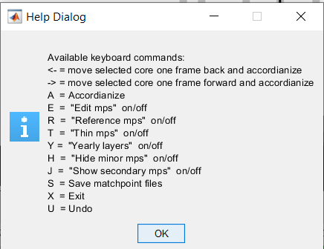

Scaling the axes
Figure 5 Depth axis buttons
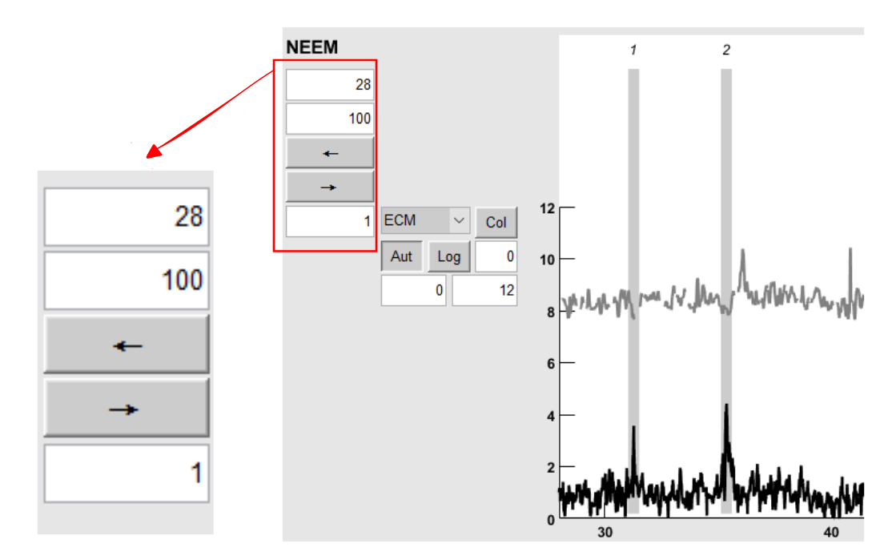
Buttons for scaling of the depth axes are located to the left of each data panel (Figure 5). The field below the arrow buttons contains the increment used when using the arrows (keyboard arrows or buttons) to move the axes

Figure 6 Species button group
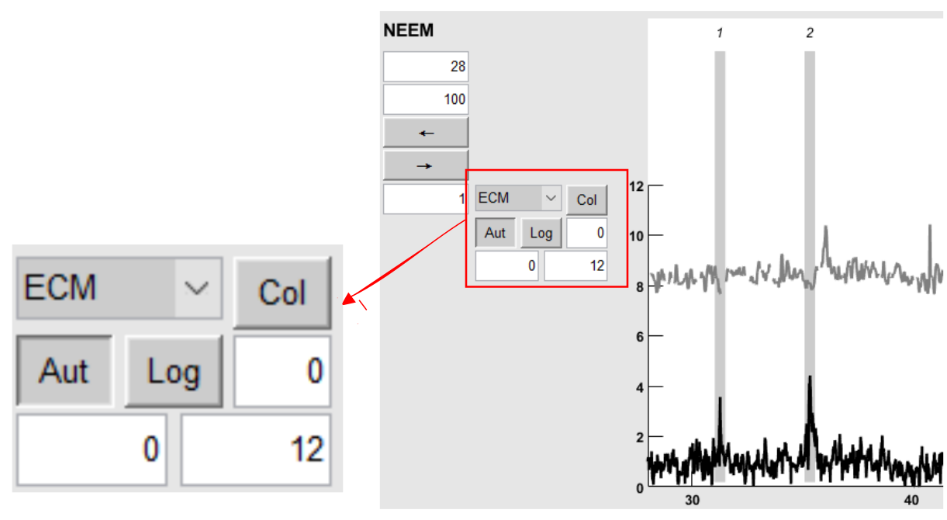

Each data sub-panel has a cluster of buttons (Figure 6).
The drop down list enables the user to change which data series (species) is shown. Next, the Color button can change the color of the data line, the new color is automatically updated.
The Aut button re-enables automatic scaling after manual scaling has been applied, and the Log button toggles logarithmic y-axis on/off.
The field next to Log sets an x-offset into the species.
The two fields underneath set the y-limits of the species.

Comparing two sets of match points
If you want to compare or review two parallel sets of match points on the same core, you can either open Matchmaker twice with the different files and settings, or instead display and edit the two sets of match points on one screen.
To do this, for the ice core in question, add a secondary set of mp under the matchfile_bis variable in the files_main file. E.g.:

files.core{1} = 'Core1';
files.datafile{1} = 'core1_data.mat';
files.matchfile{1} = 'CORE1_core123match.mat';
files.matchfile_bis{1} = 'CORE1_core123match_version2.mat';

Then open Matchmaker and press the Show secondary button. The primary match points will be reduced in height and the secondary set will appear in the lower half of each core window. Match points are modified as usual by pressing Edit and the preferred type. Upon pressing Save all files will be saved and the backup will be produced as usual.

